Resume of Raziya Sultana
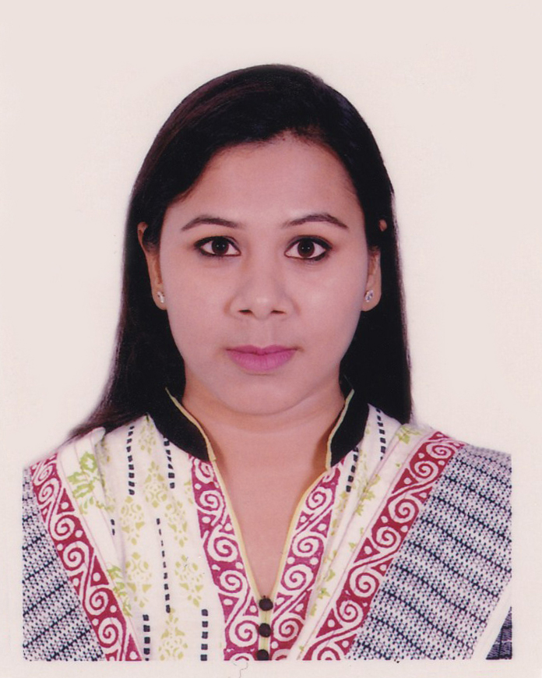
C/O. Mohammad Rafiqul Islam
493 South Monipur, Mirpur – 2, Dhaka – 1216
Mobile: 01717-418803
E-mail: rza_sta@yahoo.com

CAREER OBJECTIVE
To pursue a challenging carrier in a multicultural organization that will best utilize my skill in the Software Development sector.
EXPERIENCE
♦ | Executive (October 1, 2021 – Continue)  BITOPI GROUP.  822/3, begum rokeya sharani, shewrapara,  mirpur, dhaka 1216, Bangladesh
 | Duties/Responsibilities:
ERP Software Development (Desktop and web version in different Module).
i. To design and develop reports using CRYSTAL report.
ii. SQL queries and Store Procedure.
iii.User Support for ERP System.
iv.Provide User Training.
v. Documentation and Flowchart Design using Visio.
vi.Visit Factory to collect user requirement.
♦ | Jr.Executive (December 20, 2020 –September 30,2021)  BITOPI GROUP.  822/3, begum rokeya sharani, shewrapara,  mirpur, dhaka 1216, Bangladesh
 | Duties/Responsibilities:
ERP Software Development (Desktop and web version in different Module).
i. To design and develop reports using CRYSTAL report.
ii. SQL queries and Store Procedure.
iii. Documentation and Flowchart Design using Visio.
iv.Visit Factory to collect user requirement.
♦ | Jr.Programmar (December 8, 2018 – Continue)  National Development Engineer Ltd.  House # 10, Road # 90  Gulshan-2  Dhaka
 | Duties/Responsibilities:
ERP Software Development (Inventory & fixed asset, Costing & budgeting of BOM/BOQ, Finished goods management, HRM).
i. Practical work in C#, ASP .NET MVC 4, DHTML.
ii. To design and develop reports using RDLC report.
iii. To write SQL queries and stored procedure.
iv. Have to provide training to users.
v. To read all the documents of SRS and obey the rules of team leader.
vi. Based on the information procured in the system, decide how it is to be tested. vii. To handle multiple simultaneous tasks as issue list maintain, SRS preparing, user’s support.

♦ | Software Engineer (March 1, 2014 – July 31, 2014)  Artistry Limited  House # 364, Road # 27  New DOHS, Mohakhali  Dhaka
 | Duties/Responsibilities:
i.Work in C#, ASP.NET MVC 4
ii.To write SQL queries and stored procedure.

♦ | .Net Programmer (January 1, 2014 – February 28, 2014)  Generation Next IT Solution Ltd.  345 DIT Road, East Rampura (Ground Floor)  Dhaka  Web: http://www.gnisbd.com
 | Duties/Responsibilities:
i.Work in VB.Net
ii. Database MySQL server
ii.User Support.
♦ | EDUCATION
◻
  B.Sc. (Hons.) in EEE | University of Science and Technology Chittagong (USTC)  CGPA: 2.97  Passing Year: 2012
◻
  H.S.C. (Science) | Rajshahi Govt. City College  GPA: 4.30  Passing Year: 2006
◻
  S.S.C (Science) | Rajshahi Cantonment board high school, Rajshahi  GPA: 4.56  Passing Year: 2004
 | TRAINING
Object Oriented Programming (OOP) - ASP.Net (C#)
Bangladesh Association of Software and Information Services (BASIS)
BDBL Bhaban (5th Floor - West), 12 Kawran Bazar, Dhaka -1215
Phone: +880 2 8151196; 8144708-09, +880 96 123 BASIS(22747)
Email: secretariat@basis.org.bd
PERSONAL INFORMATION
Full Name | : | RAZIYA SULTANA
Nick Name | : | Rima
Date of Birth | : | 5th oct,1989
Marital Status | : | Married
Nationality | : | Bangladeshi
Religion | : | Islam
Language | : | Bangla
National ID No. | : | 8192215247484
Father’s Name | : | Md. Abdur Rafique
Mother’s Name | : | Mrs. Nazma begum
Mailing Address | : | Raziya Sultana  C/O. Md. Rafiqul Islam  493 South Monipur  Mirpur – 2, Dhaka – 1216.
Permanent Address | : | Raziya Sultana  C/O. Md. Rafiqul Islam  493 South Monipur  Mirpur – 2, Dhaka – 1216.
Contact No. | : | 01717-418803

LANGUAGE
♦ | Bengali | Native
♦ | English | Fluent in reading, writing and speaking

INTEREST
Computers, Badminton playing, Science & Technology, Reading book, Paintings, Meeting People, Traveling etc.
REFERENCES
Dr. Md. Aktar Uzzaman Chowdhury  Chairman  Department of Pharmacy,  University of Rajshahi  Department of Pharmacy, University of Rajshahi, Rajshahi, Bangladesh  01712792350  auchow5@yahoo.com | Mohammad Jakir Hossain Bhuiyan  Sub-Divisional Engineer (Internal)  Telephone Exchange, BTCL  BTCL, Khilgaon, Dhaka-1219  01550-151417  mohammadzakir@yahoo.com

RAZIYA SULTANA

